**Week 6 Handson**

**ReactJS -HOL**

**Ex 1.Create a new React Application with the name “myfirstreact”, Run the application to print “welcome to the first session of React” as heading of that page.**

**Steps to Create and Run Your First React App**

1. **To create a new React app, Install Nodejs and Npm from the following link:**

[**https://nodejs.org/en/download/**](https://nodejs.org/en/download/)

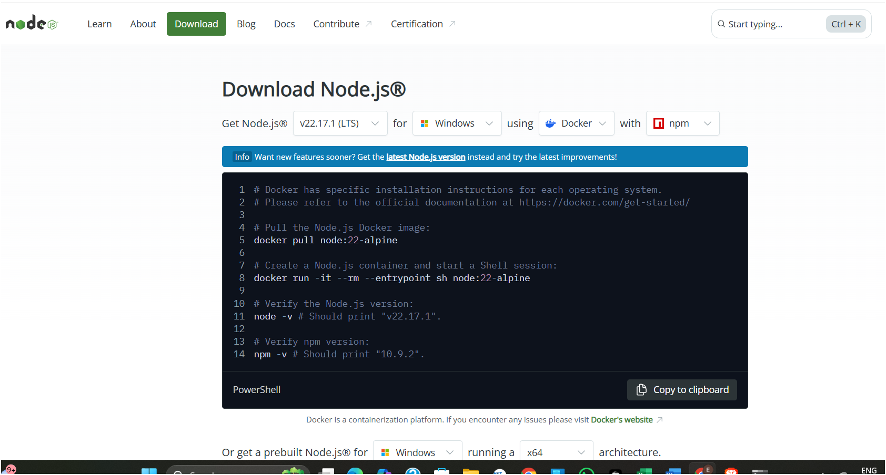

**2.Install create-react-app:**

Open your terminal or command prompt and run:

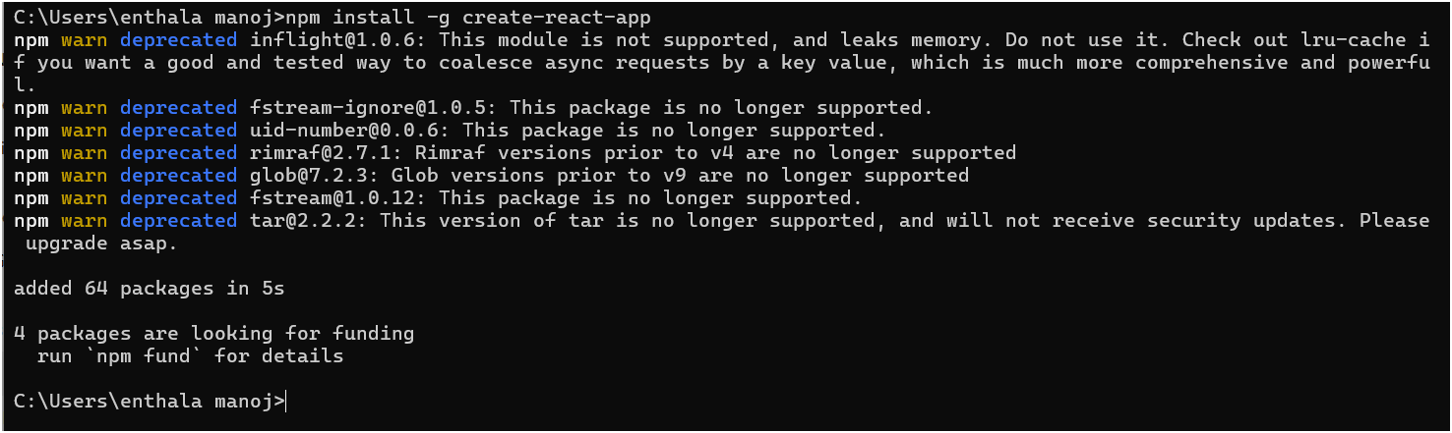

**3.Create a new React App named myfirstreact**

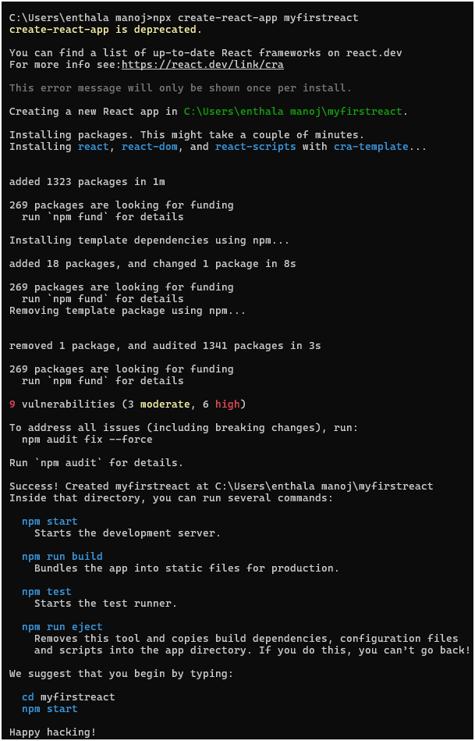 **4.Navigate into your app directory**

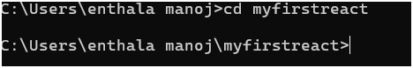

**5.** **Open project in Visual Studio Code**

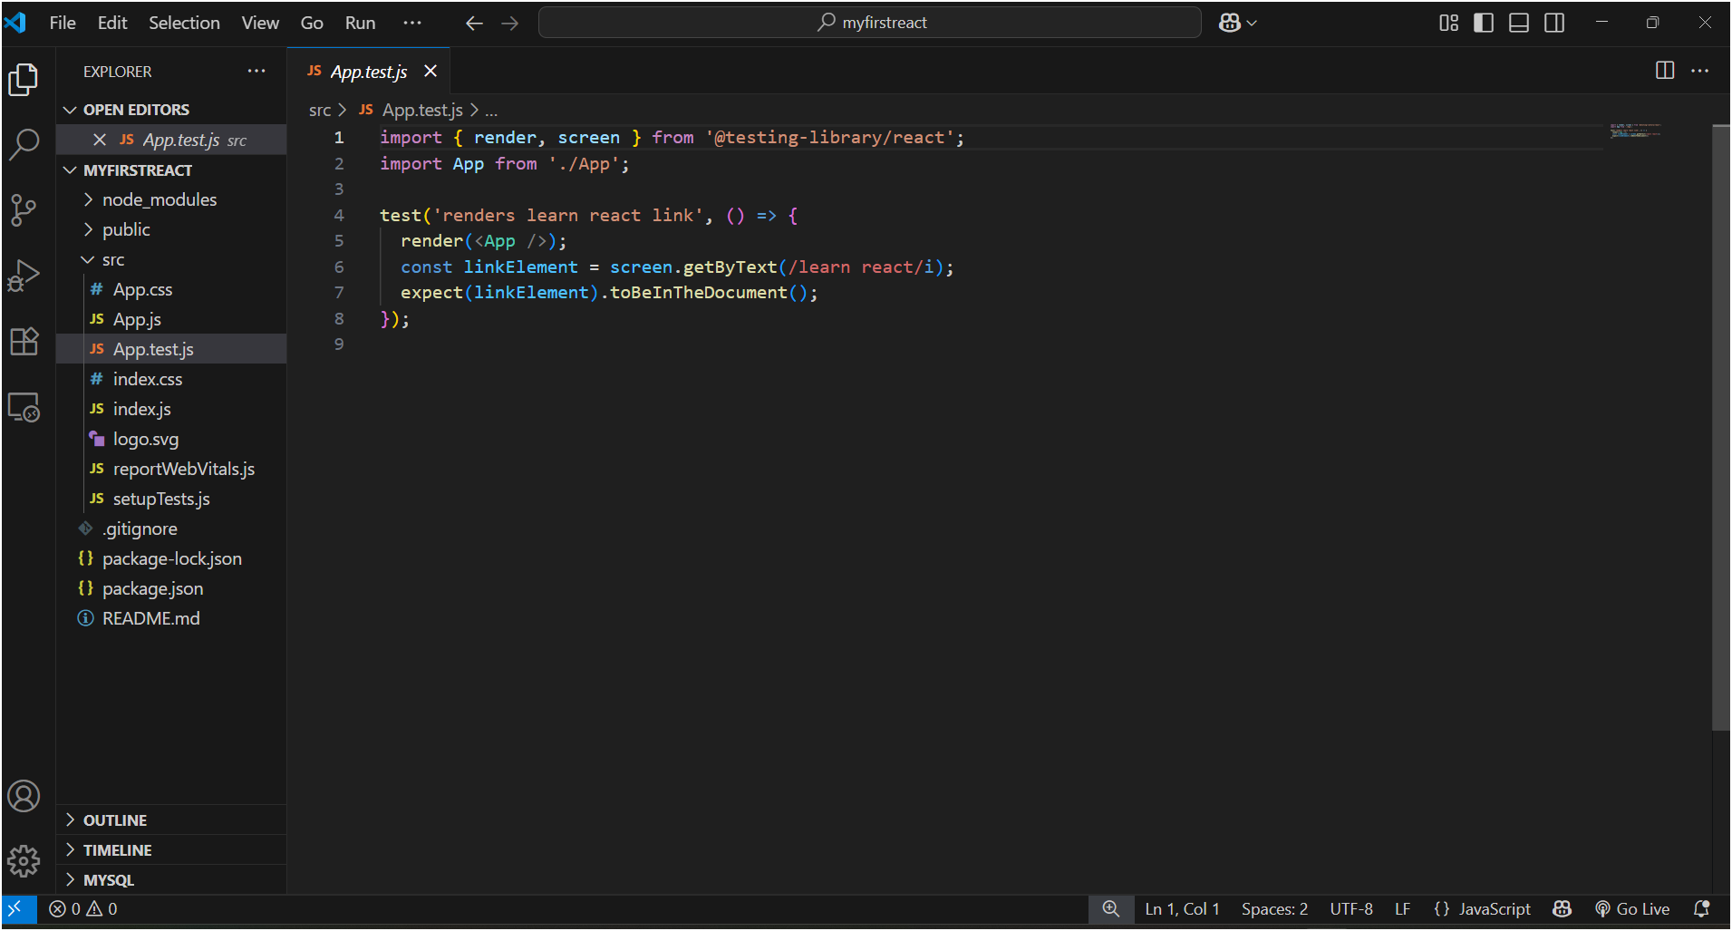

**6.** **Open the App.js file in Src Folder of myfirstreact**

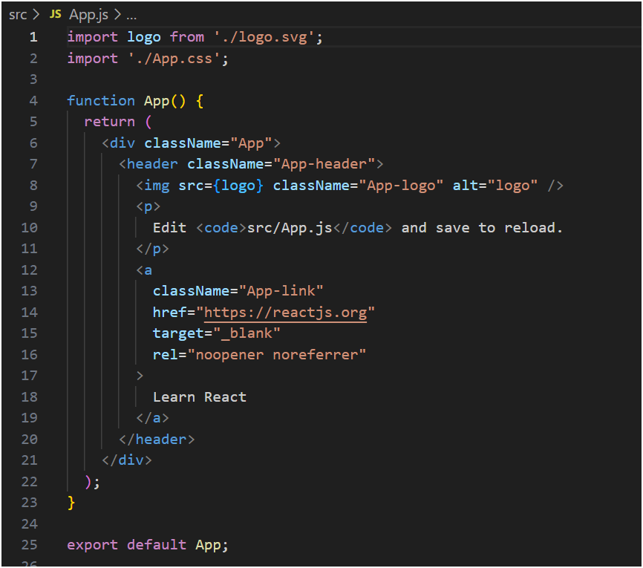

**7. Remove the current content of “App.js”**

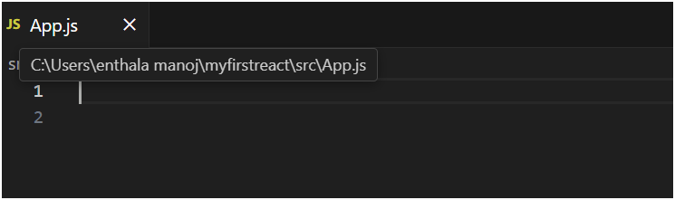

**8. Replace it with the following:**

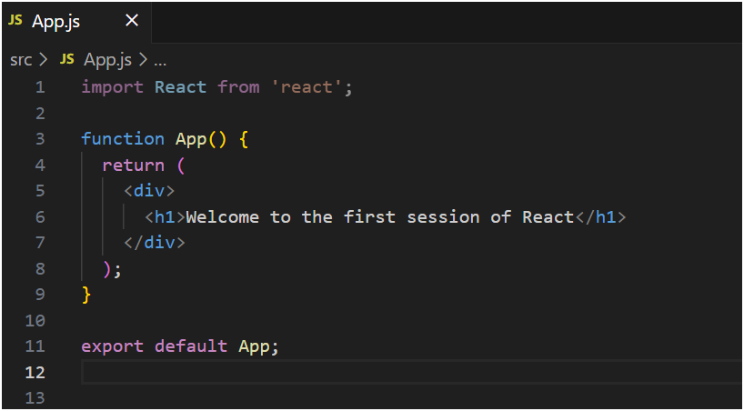

**9. Run the following command to execute the React application:**

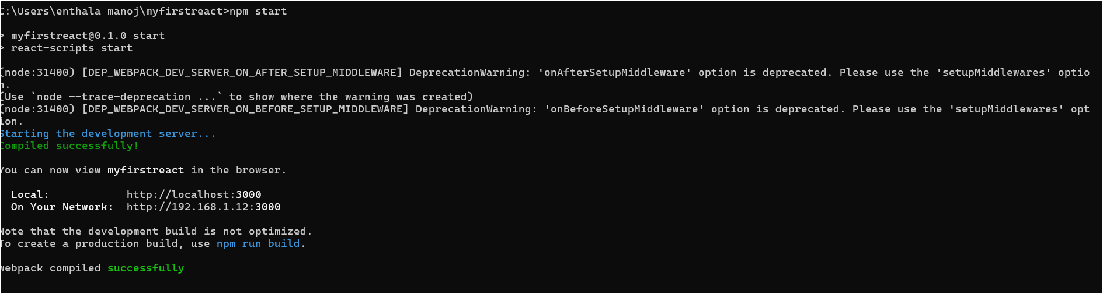

**10.** Open a new browser window and type “localhost:3000” in the address bar

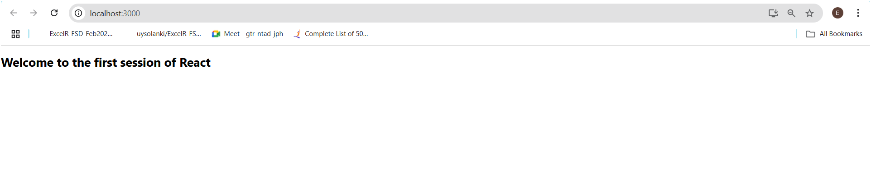

**Ex 2. Create a react app for Student Management Portal named StudentApp and create a component named Home which will display the Message “Welcome to the Home page of Student Management Portal”. Create another component named About and display the Message “Welcome to the About page of the Student Management Portal”. Create a third component named Contact and display the Message “Welcome to the Contact page of the Student Management Portal”. Call all the three components.**

**Steps to Build the Student Management Portal**

**1. Create the React Project**

In the terminal:

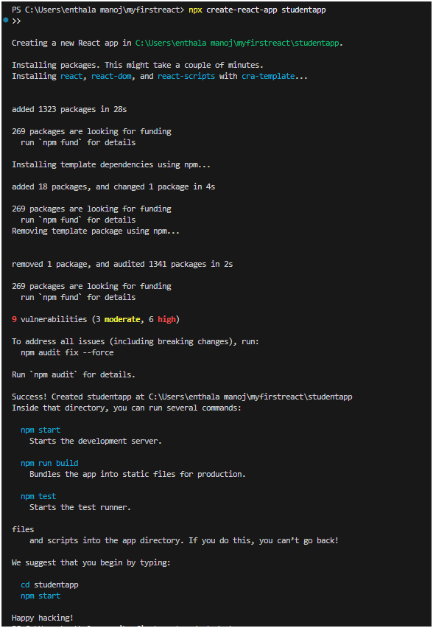

**2.Create a new folder under Src folder with the name “Components”. Add a new file named “Home.js”**

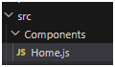

**3.Type the following code in Home.js**

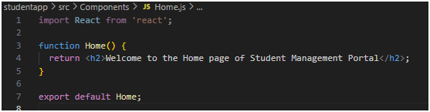

**4.** **Under Src folder add another file named “About.js”**

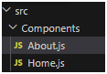

**5.** **Repeat the same steps for Creating “About” and “Contact” component by adding a new file as ”About.js”, “Contact.js” under “Src” folder and edit the code as mentioned for “Home” Component.**

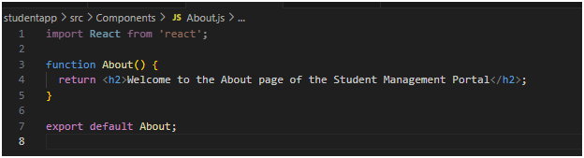

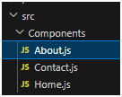

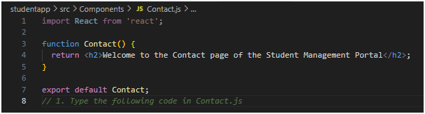

**6.Edit the App.js to invoke the Home, About and Contact component as follows:**

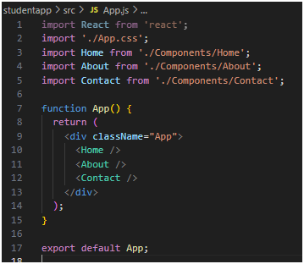

**7.** **In command Prompt, navigate into StudentApp and execute the code by typing the following command:**

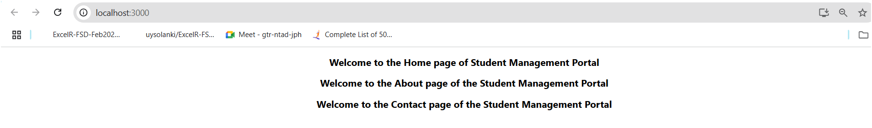

**Ex 3.Create a react app for Student Management Portal named scorecalculatorapp and create a function component named “CalculateScore” which will accept Name, School, Total and goal in order to calculate the average score of a student and display the same.**

**Component to Create: CalculateScore**

**A function component**

**Accepts the following props:**

* + **Name**
  + **School**
  + **Total**
  + **Goal**

**Calculates the average score**

**Displays the result**

1. **Create a React project named “scorecalculatorapp” type the following command in terminal of Visual studio:**

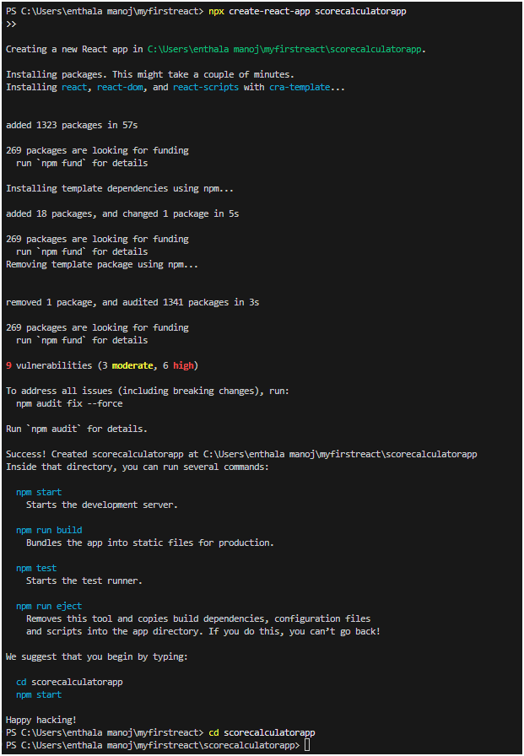

1. **Create a new folder under Src folder with the name “Components”. Add a new file named “CalculateScore.js”**

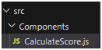

**3.Type the following code in CalculateScore.js**

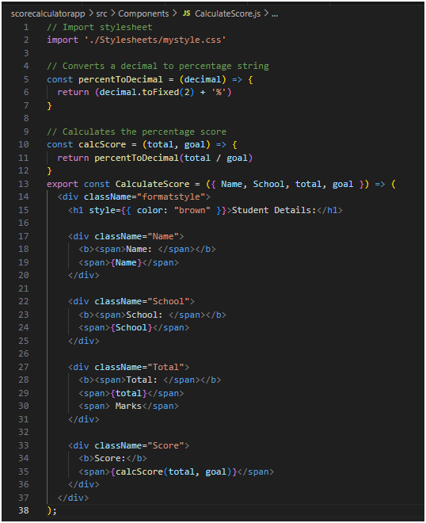

**4.**Create a Folder named Stylesheets and add a file named “mystyle.css” in order to add some styles to the components:

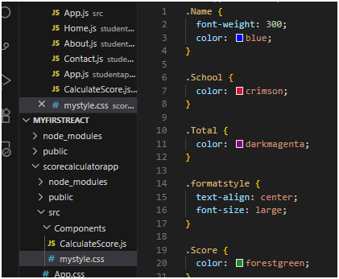

5. Edit the App.js to invoke the CalculateScore functional component as follows:

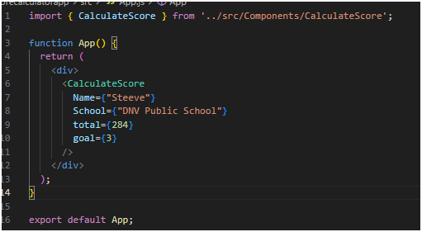

6. In command Prompt, navigate into scorecalculatorapp and execute the code by typing the following command:

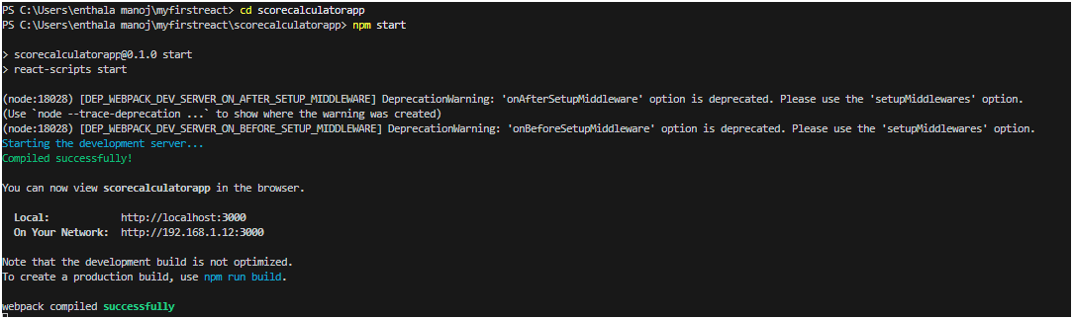

7.Open browser and type “localhost:3000” in the address bar:

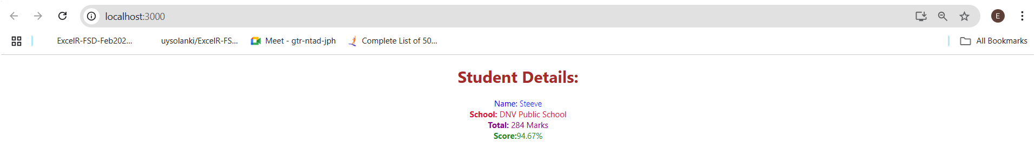

**EX 4.Create a new react application using *create-react-app* tool with the name as “blogapp”**

**1. Create a New React App**

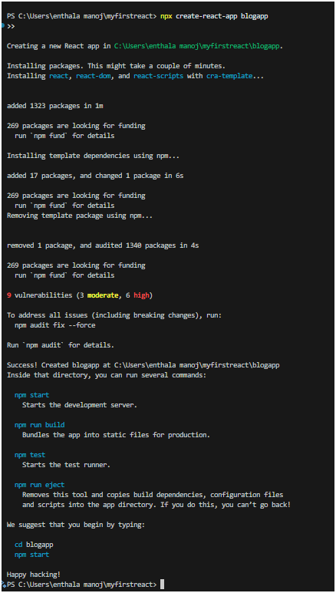

2.Open the application using VS Code

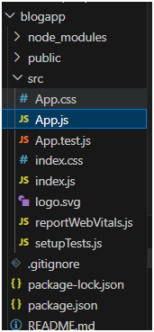

3.Create a new file named as **Post.js** in **src folder** with following properties

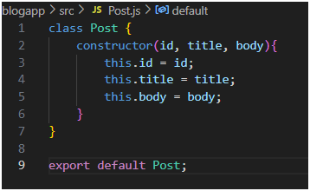

4.Create a new class based component named as **Posts** inside **Posts.js** file

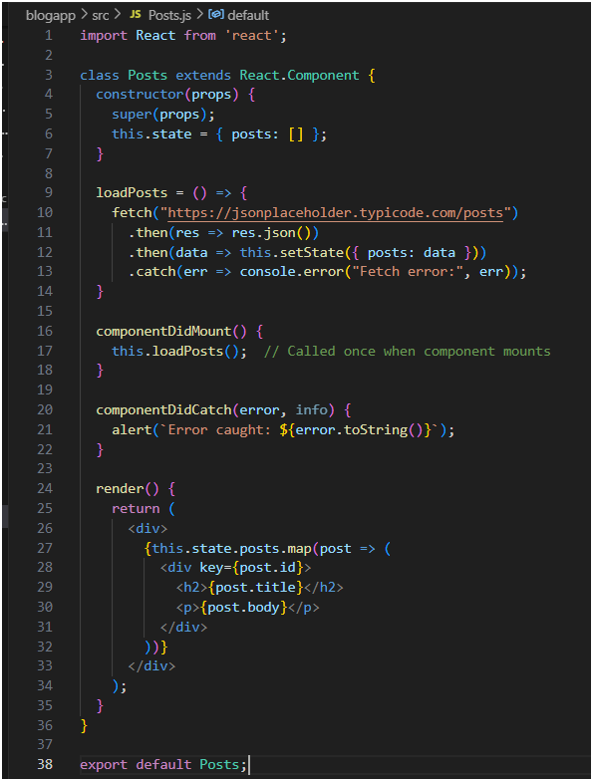

5. Integrate with App Component

In App.js, import and use Posts:

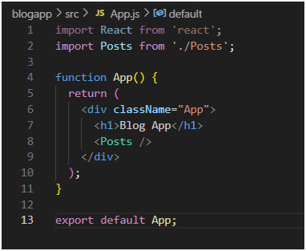

Step5: run application by “npm start” in terminal

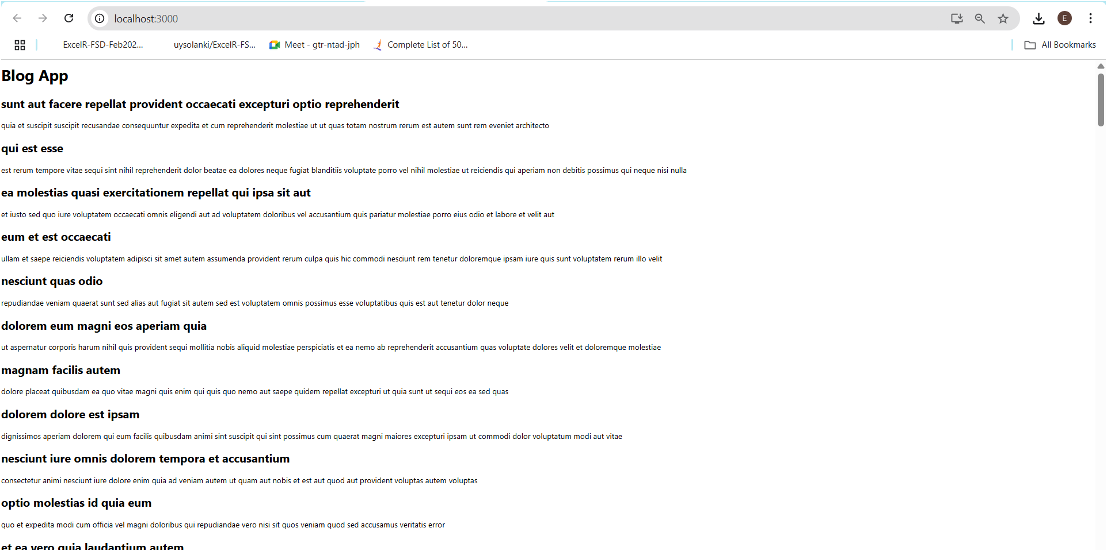

**Ex 5:My Academy team at Cognizant want to create a dashboard containing the details of ongoing and completed cohorts. A react application is created which displays the detail of the cohorts using react component. You are assigned the task of styling these react components.**

**Download and build the attached react application.**

**1.**Restore the node packages using the following commands

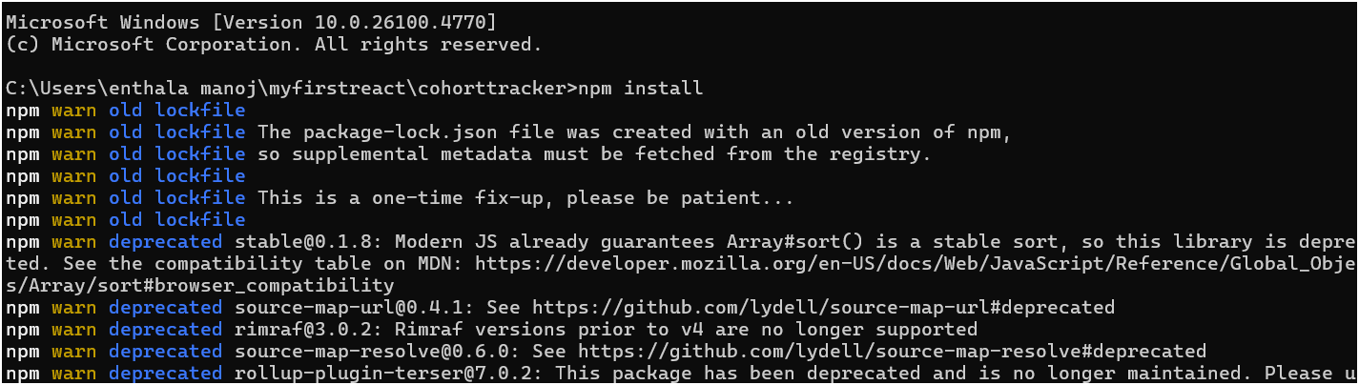

2.Open the application using VS Code

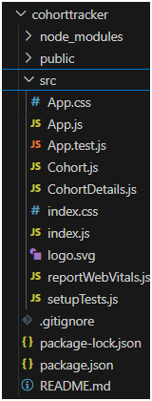

3.Create CSS Module

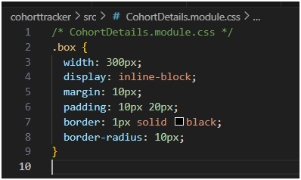

4.Style the <dt> HTML Tag

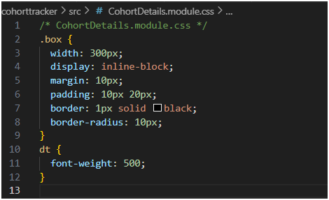

5. **Import CSS Module in Component**

In your CohortDetails.js

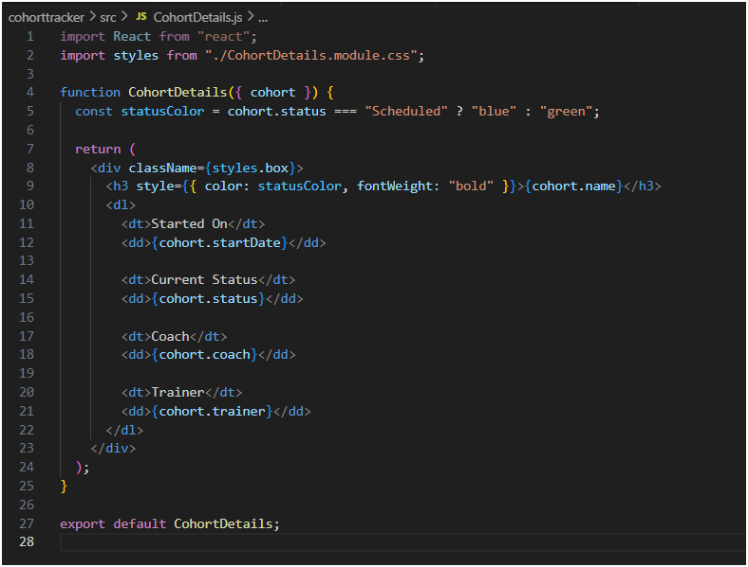

6. Step4: run ”npm start” in terminal  
here we can see that green-ongoing, blue-scheduled

